*Lucrare laborator 3*

*Cimpeanu Ana-Maria*

**Masurarea rezistentelor electrice cu ajutorul Volmetrului si Ampermetrului .**

**Metodele Amonte și Aval.**

B

**1.1Teoria lucrarii**

A

I

Lucrarea are la baza Legea lui OHM : U=I*R

U : reprezinta tensiunea masurata cu volmetru conectat in paralel cu rezistorul.

I: reprezinta intensitatea curentului electric masurat in ampere ,conectat in serie cu rezistorul.

Conexiunea celor doua se realizeaza prin montajul aval sau montajul amonte.

Fiecarea montaj in parte produc o erorare sistematica ,diferita in ambele cazuri . In montajul amonte volmetrul masoara si o tensiune care include tensiunea bornelor ampermetrului ,iar montajul aval si curentul care trece prin volmetru.Astfel, se vor face corectii pentru fiecare caz.

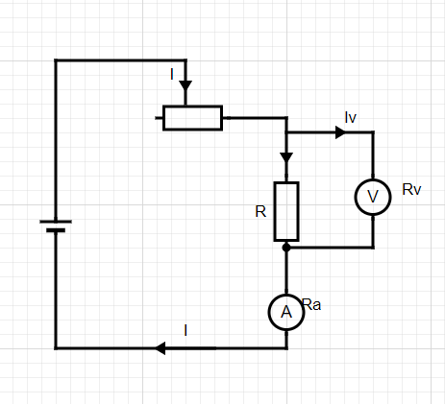**1.2.MONTAJE EXPERIMENTALE**

R1= U/I (valoare eronata )

R= U/IR = U/(I-Iv) = U/(I-U/Rv) (1)

Volmetru masoara U

Ampermetru masoara I

(Aval)



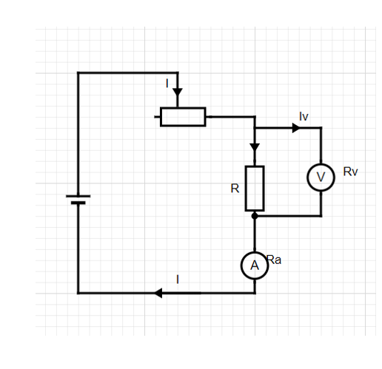

R1= U/I

R=UR/I=(U-UA)/I=(U-RAI)/I (2)

(Amonte)

**1.3.Scopul lucrarii**

Acesta consta in a studia care din cele doua montaje implica o eroare mai mica (pentru care dintre ele ,raportul U/I este mai apropiat de rezistenta adevarata R).

Primul montaj (AVAL) implica o eroare din cauza ca Ampermetrul masoara un current (I) diferit fata de curentul care trece prin rezistor (IR).

Al doilea montaj (AMONTE) implica o eroare deoarece Volmetrul masoara o tensiune (U) diferita de tensiunea (UR) pe rezistor . Nu putem scapa de erori. Cee ace putem face este sa cercetam care eroare este mai mica .

Eroarea este evaluate prin marimea **ɛ**= | (R1-R)/R | si este numita eroare relativa .

**ɛ** depinde de R ( rezistenta adevarata) . O dependenta a lui **ɛ** de R arata astfel :

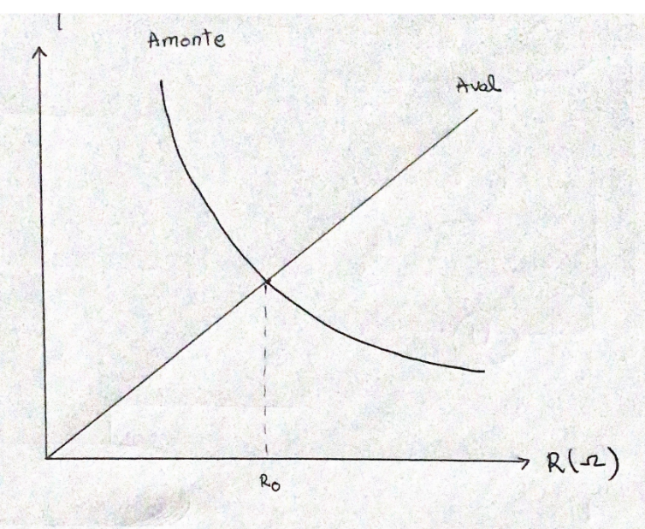

Pentru montajul AVAL :

- Daca R<<Rv (rezistente mici) => IR ~ I => erori mici

- Daca R~RV (rezistente mari) => IR ~ I/2 => erori mari

- Montajul AVAL este bun pentru R mici si prost pentru R mare

Pentru montajul AMONTE :

- Daca R~RA (rezistenta mici ) => UR ~ U/2 => erori mari

- Daca R>>RA (rezistente mari) => UR ~ U => erori mici

- Montajul AMONTE este buna la R mari si prost la R mici.

Cu ajutorul acestui Grafic calitativ , criteriul de mic sau mare , devine mai clar .Exista R0 pentru care cele doua erori sunt la fel de mari.

Daca -> R < R0 este buna metoda AVAL

-> R>R0 este buna metoda AMONTE

(1) R=U/(I-U/RV) (AVAL)

(2) R=(U-RAI)/I (AMONTE)

**ɛAV = =**

**R = 🡪 RI - = U 🡪 RI = /*RV 🡪 RVRI = U(1+R) 🡪**

**ɛam = = = = =**

**(2) : R = ⬄ R = – RA => = R + RA  => ɛam  = => ɛam  = =**

**ɛam =**

**=**

**R2 = RRA - RVRA**

**Δ = R2A + 4RVRA**

**R1, 2 = , dar R > 0**

**R0 = , R0 – teoretic**

**R0 ≈ =**

**R0 ≈**

Vom lucra pe scala de 10V CC (current continuu) cu volmetru pentru care RV = 200.000Ω.

Vom lucra cu ampermetrul pe scala de 10mA CC pentru care RA=9Ω

R0,theoretic ~

RV=200.000Ω => R0,theoretic ~ 1342 Ω

RA=9Ω

**1.4.PRELUCRAREA DATELOR EXPERIMENTALE**

**1.Aval**

|  |  |  |  |  |
| --- | --- | --- | --- | --- |
| **Cobai(Ω)** | **U(V)** | **R1=U/I(Ω)** | **R = 𝑈−9𝐼 /𝐼 (Ω)** | **ɛ=** |
| **400** | **3,2 V** | **376,4705** | **367,4705** | **0,0244** |
| **500** | **3,4 V** | **472,(2)** | **463,2222** | **0,0194** |
| **600** | **3,5V** | **564,5161** | **555,5161** | **0,0162** |
| **700** | **3,6V** | **666,6666** | **657,6666** | **0.0133** |
| **800** | **3,7V** | **770,8(3)** | **761,8333** | **0.0118** |
| **900** | **3,8V** | **863,6363** | **854,6363** | **0,0105** |
| **1000** | **8,2V** | **931,8181** | **922,8181** | **0,0097** |
| **1100** | **8,3V** | **1.037,5** | **1028,5000** | **0,0087** |
| **1200** | **8,4V** | **1.135,1351** | **1126,1351** | **0,0079** |
| **1300** | **8,4V** | **1.217,3913** | **1208,3912** | **0,0076** |
| **1400** | **8,4V** | **1.312,5** | **1303,5000** | **0,0066** |
| **1500** | **8,4V** | **1,377,0491** | **1368,0490** | **0,0065** |
| **1600** | **8,5V** | **1,491.2280** | **1482,2280** | **0,0060** |
| **1700** | **8,6V** | **1,592.5925** | **1583,5925** | **0,0056** |
| **1800** | **8,6V** | **1,686.2745** | **1677,2744** | **0,0053** |
| **1900** | **8,6V** | **1,791.6666** | **1782,6667** | **0,0050** |
| **2000** | **8,6V** | **1,869.5652** | **1860,5654** | **0,0390** |
| **2100** | **8,6V** | **1,954.5454** | **1945,5454** | **0,0046** |
| **2200** | **8,6V** | **2,047.6190** | **2038,6192** | **0,0044** |
| **2300** | **8,6V** | **2.150** | **2141,0000** | **0,0042** |
| **2400** | **8,6V** | **2,205.1282** | **2196,1284** | **0,0040** |

**2.AMONTE**

|  |  |  |  |  |  |
| --- | --- | --- | --- | --- | --- |
| **Cobai(Ω)** | **U(V)** | **I(A)** | **R1=U/I(Ω)** | **R = 𝑈−9𝐼 /𝐼 (Ω)** | **ɛ=** |
| **400** | **3,6V** | **0,009** | **400** | **391** | **0,0230** |
| **500** | **3,7 V** | **0,0077** | **480,5194** | **471,5185** | **0,0190** |
| **600** | **3,8V** | **0,0065** | **584,6153** | **575,6153** | **0,0156** |
| **700** | **4V** | **0,0058** | **689,6551** | **680,6551** | **0.0132** |
| **800** | **4V** | **0,0052** | **769,2307** | **760,2307** | **0,0118** |
| **900** | **4V** | **0,0046** | **869,5652** | **860,5651** | **0,0104** |
| **1000** | **4,1V** | **0,0042** | **4,0958** | **967,1905** | **0,0093** |
| **1100** | **4,2V** | **0,0039** | **1.076,9230** | **1067,9230** | **0,0084** |
| **1200** | **8,4V** | **0,0075** | **1.120** | **1111** | **0,0081** |
| **1300** | **8,4V** | **0,0067** | **1,253,7313** | **1244,7313** | **0,0072** |
| **1400** | **8,4V** | **0,0063** | **1.333,3333** | **1324,3332** | **0,0067** |
| **1500** | **8,4V** | **0,0059** | **1.423,7288** | **1414,7287** | **0,0063** |
| **1600** | **9V** | **0,0056** | **1.607,1428** | **1598,1429** | **0,0059** |
| **1700** | **9V** | **0,0053** | **1.698,1132** | **1689,1132** | **0,0056** |
| **1800** | **9V** | **0,005** | **1.800** | **1791** | **0,0053** |
| **1900** | **9V** | **0,0048** | **1.875** | **1866** | **0,0050** |
| **2000** | **9V** | **0,0044** | **2.045,4545** | **2036,4544** | **0,0048** |
| **2100** | **9V** | **0,0041** | **2.195,1219** | **2186,1220** | **0,0044** |
| **2200** | **8,6V** | **0,0039** | **2.202,1282** | **2196,1284** | **0,0027** |
| **2300** | **8,6V** | **0,0038** | **2.263,1578** | **2254,1579** | **0,0039** |
| **2400** | **8,6V** | **0,0039** | **2.205,1282** | **2196,1284** | **0,0040** |

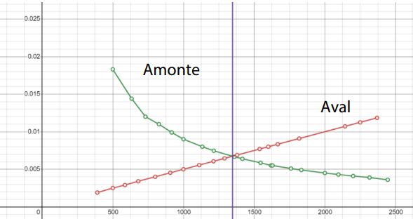

**1.5.Concluzii**

-Metoda aval este benefica pentru rezistente mici , in timp cea amonte este benefica pentru rezistente mari , iar R theoretic este egal pentru ambele metode (~ 1340Ω).